Part 1: Network topologies design and simulation using cisco packet tracer
Task2: Hybrid Topology
A hybrid topology is a network architecture that combines two or more different standard topologies (such as star, bus, ring, or mesh) to form a single, composite network. It is designed to leverage the strengths of each constituent topology while mitigating their individual weaknesses. The goal is to create a flexible, scalable, and efficient network that meets specific organizational needs, which a single, pure topology cannot achieve.
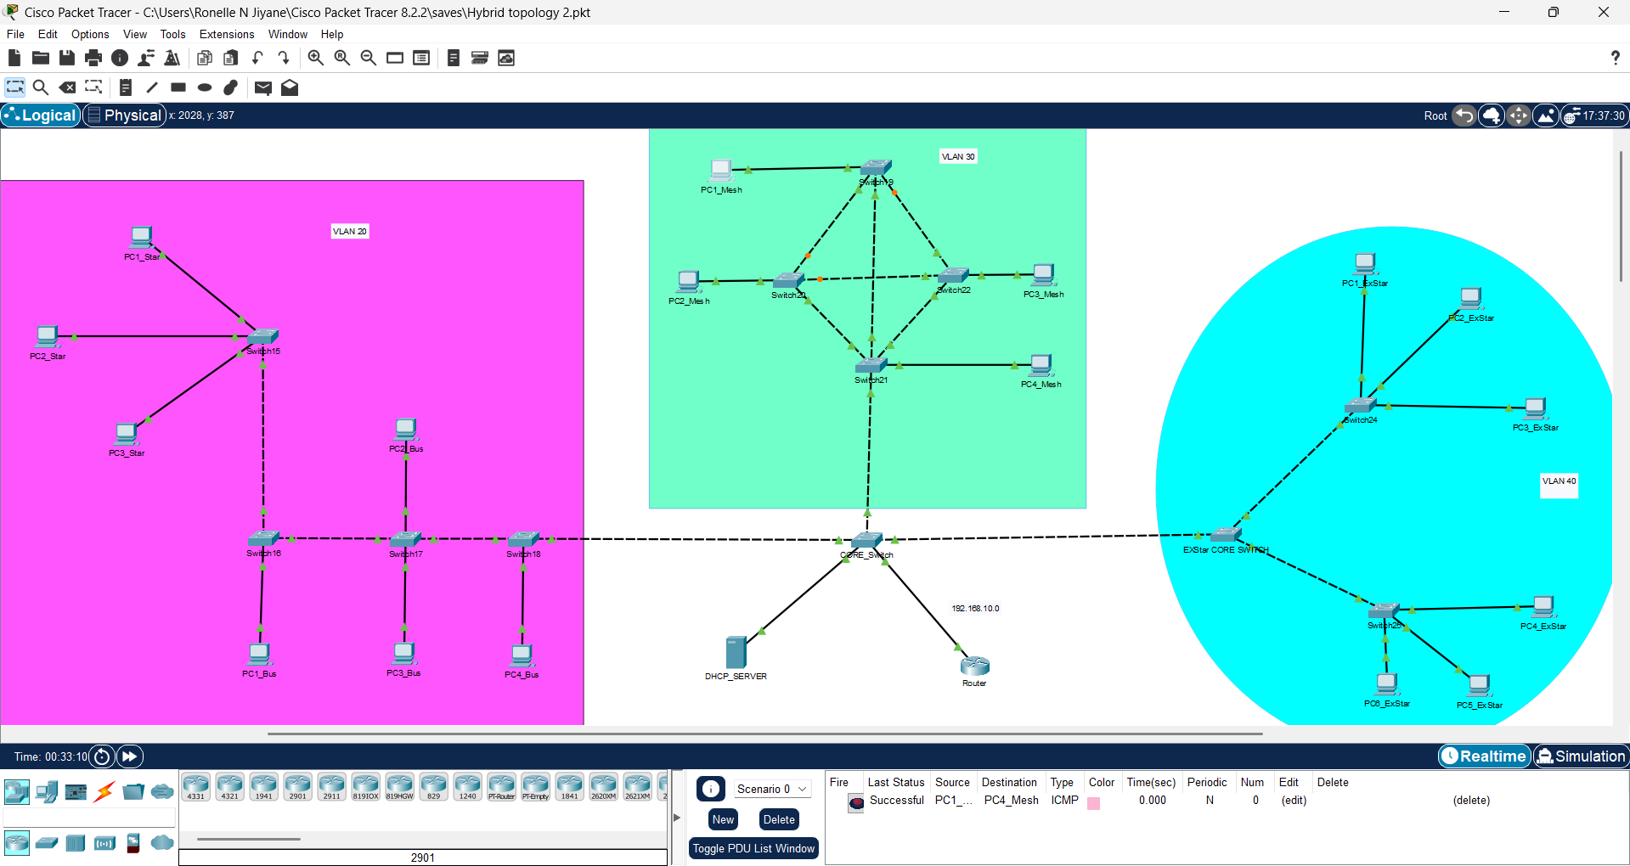
IP Tables
VLAN20
DEVICE NAME | IPv4 Address (DHCP) | IPv6 Address | Subnet Mask | Default Gateway
PC1_STAR | 192.168.10.7 | 2001:DB8:20::11 | 255.255.255.0 | 2001:DB8:20::1
PC2_STAR | 192.168.10.2 | 2001:DB8:20::12 | 255.255.255.0 | 2001:DB8:20::1
PC3_STAR | 192.168.10.13 | 2001:DB8:20::13 | 255.255.255.0 | 2001:DB8:20::1
PC1_Bus | 192.168.10.6 | 2001:DB8:20::14 | 255.255.255.0 | 2001:DB8:20::1
PC2_Bus | 192.168.10.8 | 2001:DB8:20::15 | 255.255.255.0 | 2001:DB8:20::1
PC3_Bus | 192.168.10.14 | 2001:DB8:20::16 | 255.255.255.0 | 2001:DB8:20::1
PC4_Bus | 192.168.10.11 | 2001:DB8:20::17 | 255.255.255.0 | 2001:DB8:20::1
VLAN30
DEVICE NAME | IPv4 Address (DHCP) | IPv6 Address | Subnet Mask | Default Gateway
PC1_Mesh | 192.168.10.3 | 2001:DB8:30::11 | 255.255.255.0 | 2001:DB8:30::1
PC2_Mesh | 192.168.10.10 | 2001:DB8:30::12 | 255.255.255.0 | 2001:DB8:30::1
PC3_Mesh | 192.168.10.9 | 2001:DB8:30::13 | 255.255.255.0 | 2001:DB8:30::1
PC4_Mesh | 192.168.10.12 | 2001:DB8:30::14 | 255.255.255.0 | 2001:DB8:30::1
VLAN40
DEVICE NAME | IPv4 Address (DHCP) | IPv6 Address | Subnet Mask | Default Gateway
PC1_EXSTAR | 192.168.10.17 | 2001:DB8:40::11 | 255.255.255.0 | 2001:DB8:40::1
PC2_EXSTAR | 192.168.10.18 | 2001:DB8:40::12 | 255.255.255.0 | 2001:DB8:40::1
PC3_EXSTAR | 192.168.10.16 | 2001:DB8:40::13 | 255.255.255.0 | 2001:DB8:40::1
PC4_EXSTAR | 192.168.10.15 | 2001:DB8:40::14 | 255.255.255.0 | 2001:DB8:40::1
PC5_EXSTAR | 192.168.10.4 | 2001:DB8:40::15 | 255.255.255.0 | 2001:DB8:40::1
PC6_EXSTAR | 192.168.10.5 | 2001:DB8:40::16 | 255.255.255.0 | 2001:DB8:40::1
Configuration Notes
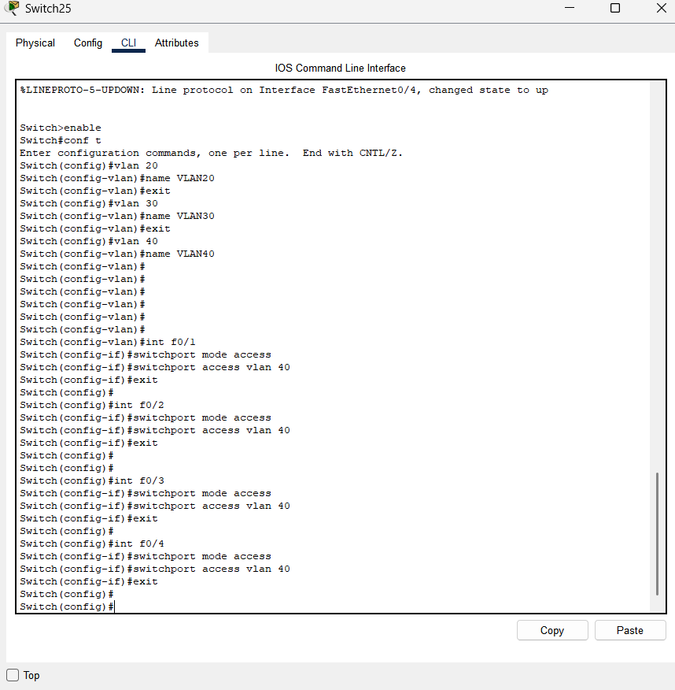
The above picture shows the configuration of switch25 which is in LAN40, in the extended star topology of the hybrid topology. This is how all the other switches were configured in the network.
The following picture shows the configuration of the router.
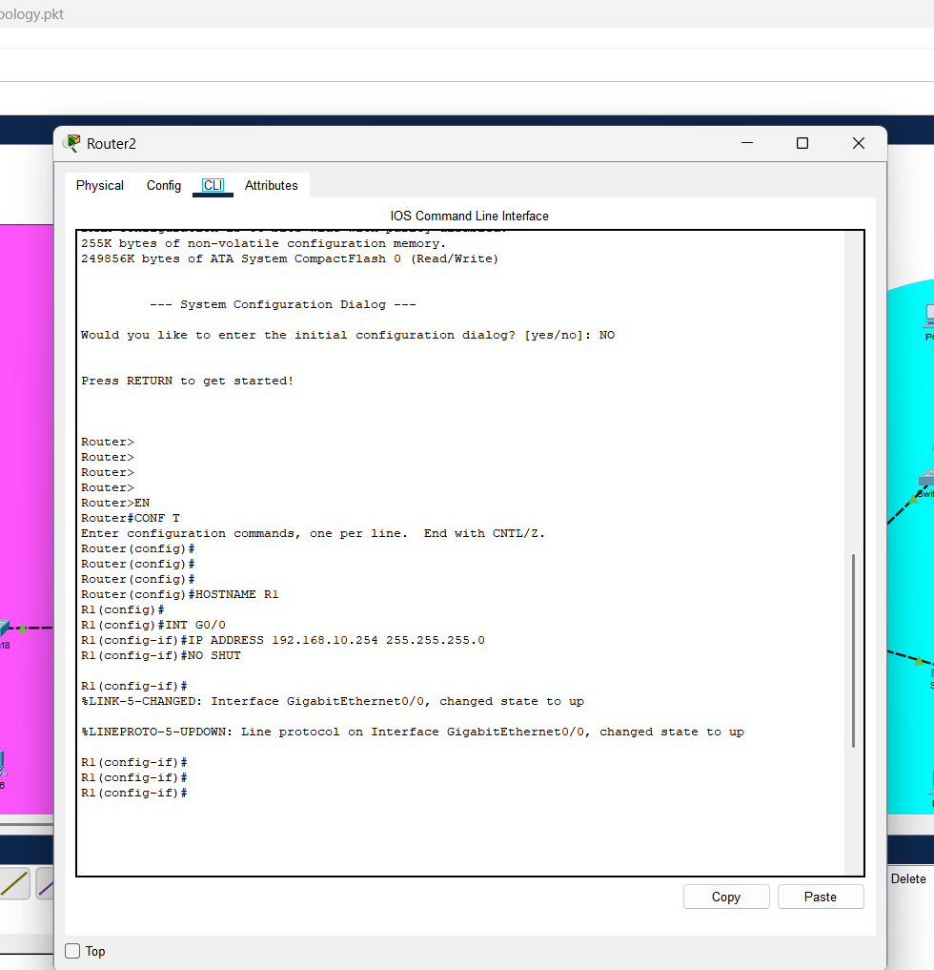
Router performs Inter-VLAN routing and forwards DHCP requests.
DHCP Server holds one pool for all VLANs.
Core Switch links everything and carries VLAN tags.
Core switch configuration
Switch> enable
Switch# configure terminal
Switch(config)# vlan 20
Switch(config-vlan)# name VLAN20
Switch(config-vlan)# exit
Switch(config)# vlan 30
Switch(config-vlan)# name VLAN30
Switch(config-vlan)# exit
Switch(config)# vlan 40
Switch(config-vlan)# name VLAN40
Switch(config-vlan)# exit
DHCP Config.
The IP configuration of the server was set manually to 192.168.10.1 for IPv4 and 2001:DB8:20::21/64.
Then turned it into the DHCP server and created a new pool 192.168.10.0, with the default gateway as 192.168.10.1 and the DNS server as 192.168.10.1 as well. Setting the starting address as 192.168.10.50.
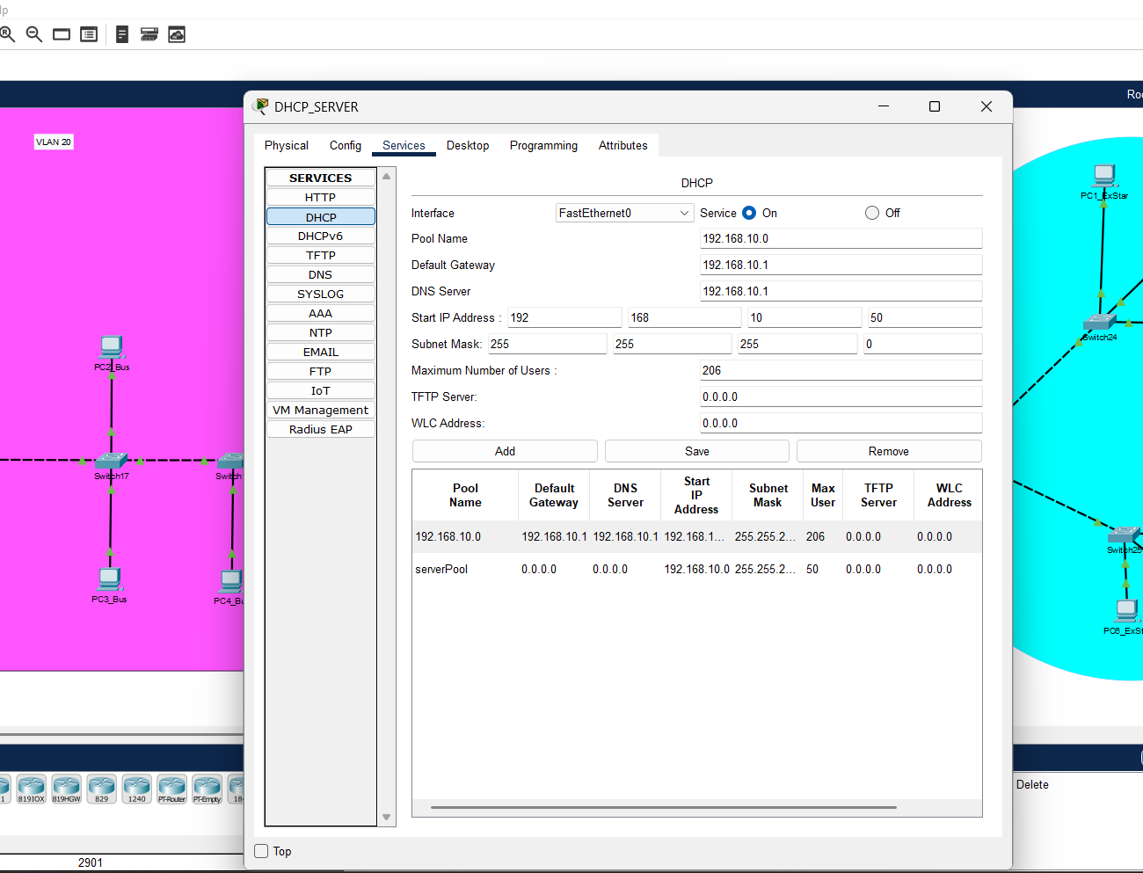
VLAN segmentation (Virtual Local Area Network segmentation) is the process of dividing a single physical network into multiple logical networks.
For VLAN segmentation
>>enable
>>configure terminal
>>interface vlan1
>>ip address 192.168.1.X 255.255.255.0
>>no shut
>>exit until conf is gone
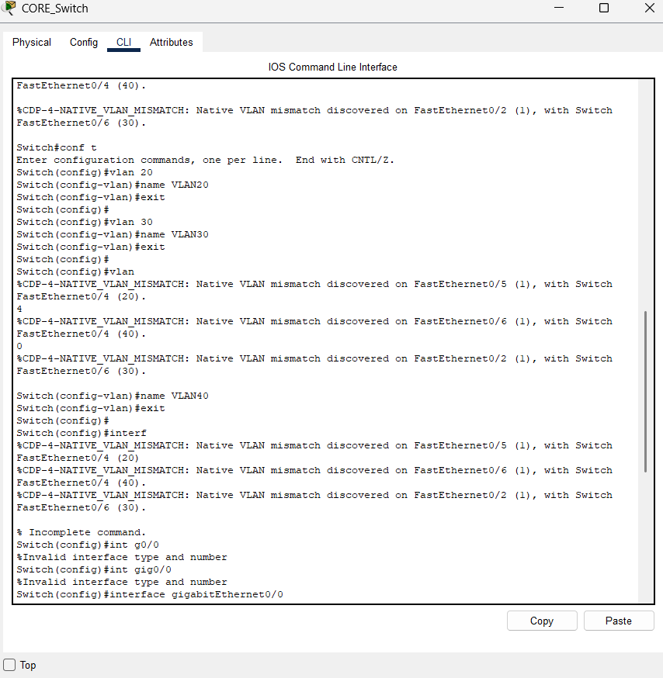
For basic security ( on each switch under CLI)
Switch>enable
Switch#configure terminal
Switch(config)#enable password @Maronza
Switch(config)# exit

